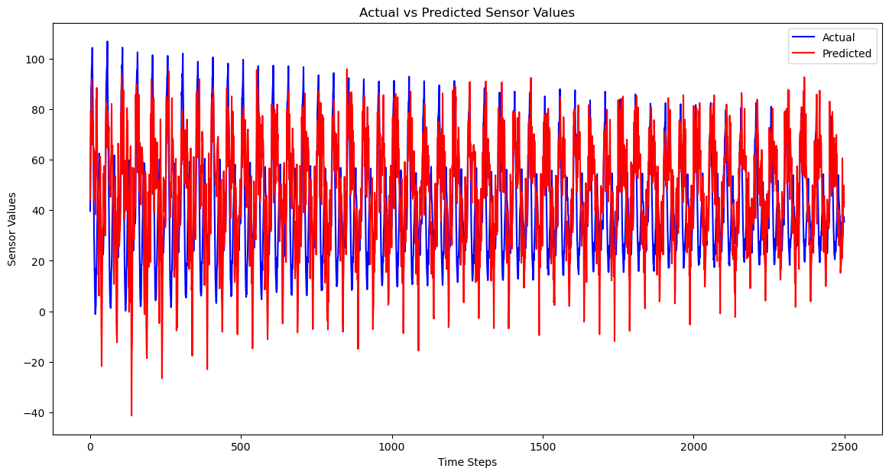

Epoch 50 batch size 50

Validation MSE: 104.98460685386434

Validation MAE: 7.8620595498961015

Validation R² Score: 0.5110114505328668

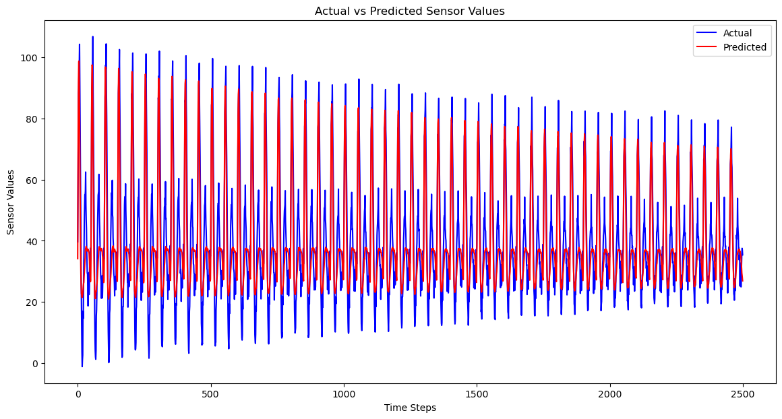

Epoch 100 batch size 50

Validation MSE: 112.83147431156058

Validation MAE: 8.034746388431337

Validation R² Score: 0.4732948310808837

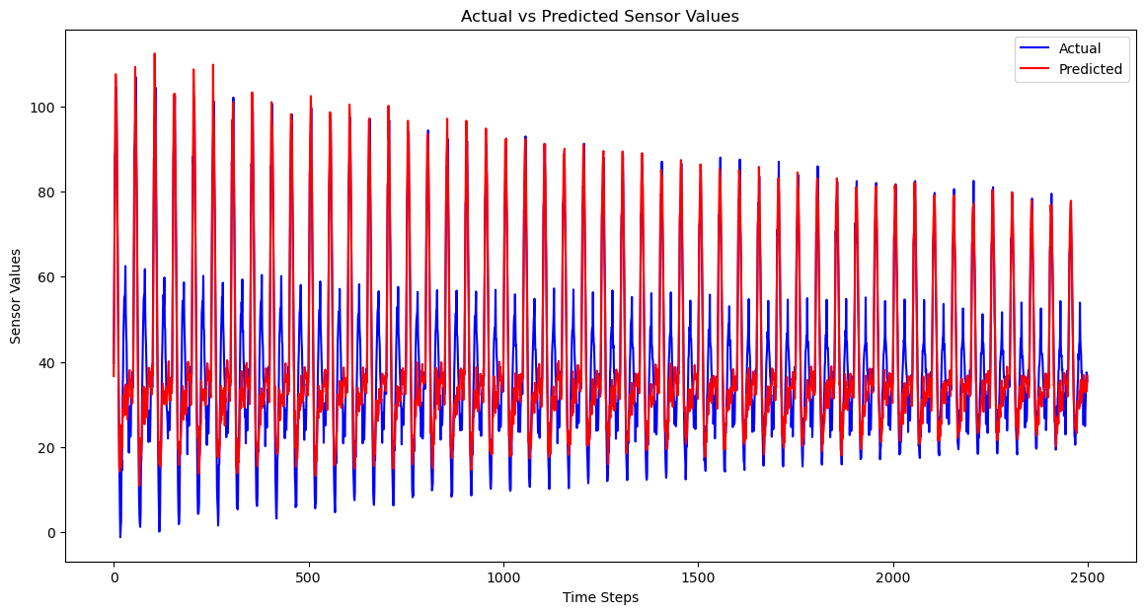

100 100 bad

100 25

Validation MSE: 9.522931322665535

Validation MAE: 2.279512395872909

Validation R² Score: 0.943780175316643

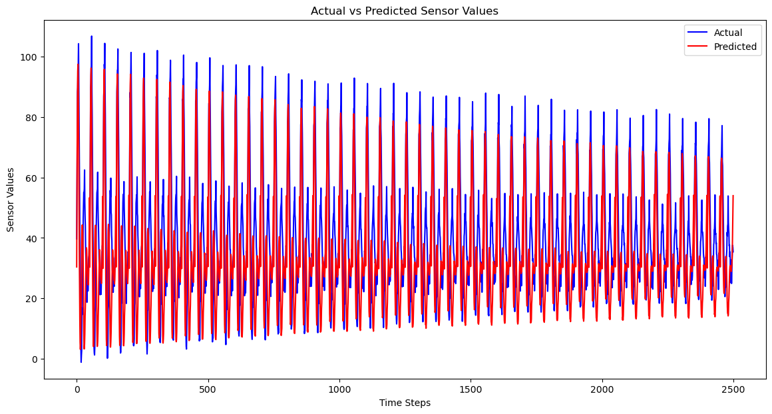

150 25

Validation MSE: 9.162544107806895

Validation MAE: 2.2263299923244566

Validation R² Score: 0.946523008021278

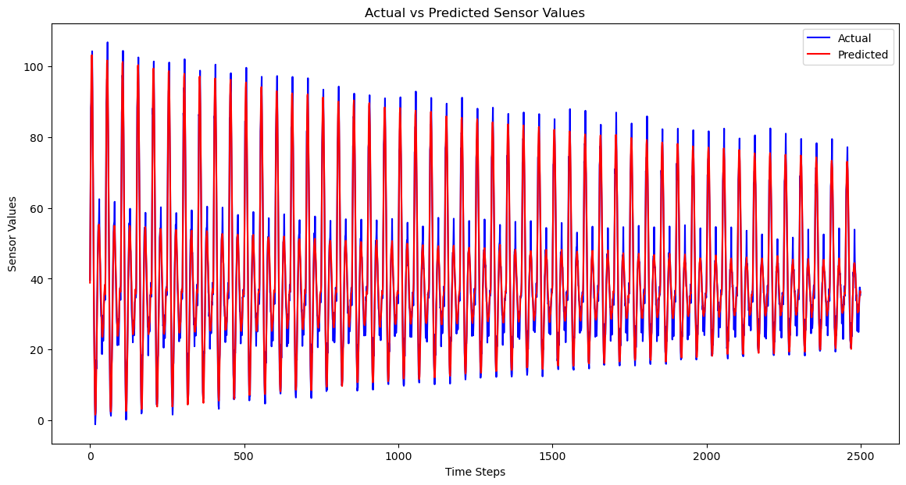

200 50

Worse than 150 25

200 25

Worse

400 25

175 25 best for now

2 layers 175 25

Validation MSE: 16.323018167016965

Validation MAE: 2.8567785717623555

Validation R² Score: 0.9150520413949638

2 layers 175 25 learning rate 0.0005

Validation MSE: 10.74577963063542

Validation MAE: 2.4108046047966383

Validation R² Score: 0.9396765448831266

Not good

2 layers 175 25 lr 0.0008 drop out layers

Not good enough

Validation MSE: 58.483613147785306

Validation MAE: 6.135659019227539

Validation R² Score: 0.6888111145006909

1 layer lstm 2 layer dense 200 25 lr 0.0005

Not good again

Trying standardization

Well, it went well